 | BAHRIA UNIVERSITY, (Karachi Campus)  Department of Software Engineering  Assignment#4 - Spring 2023

COURSE TITLE: Linear Algebra COURSE CODE: Gsc-121
Class: BSE-2(A, B, C) Shift: Morning
Course Instructor: Muhammad imran afridi Time Allowed: 3 Days
Submission Date: 17Jun 2023 Max. Marks: 5 Marks

Assignment No. 04, (CL03) [5 Marks]

Q1: - is is an Eigen value of 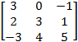? If so, compute the corresponding Eigen Vector.

Q2: - Evaluate the characteristics polynomial and compute all the real Eigen values corresponding of the given 3x3 matrix.

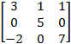

Q3:- Find the coordinate vector of relative to the given basis

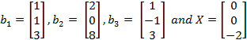
Q4:- Check that the column of the matrix 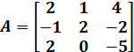 are orthogonal to each other or not. If there columns are orthogonal then write 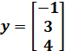 as a linear combination the columns of matrix “A

